WEB DESIGNING AND CLOUD FOUNDATIONS :
PRACTICAL 3:
Q.3 Write a HTML code to illustrate the usage of the following :
(i) Order List
(ii) Unordered List
(iii) Description List
HTML CODE:
<!DOCTYPE html>
<html>
<head>
<title>HTML Lists</title>
</head>
<body>
<h2>1. Ordered List</h2>
<ol>
<li>HTML</li>
<li>CSS</li>
<li>JavaScript</li>
</ol>
<h2>2. Unordered List</h2>
<ul>
<li>C++</li>
<li>Python</li>
<li>Java</li>
</ul>
<h2>3. Description List</h2>
<dl>
<dt>HTML</dt>
<dd>HyperText Markup Language</dd>
<dt>CSS</dt>
<dd>Cascading Style Sheets</dd>
<dt>JS</dt>
<dd>JavaScript</dd>
</dl>
</body>
</html>
<h2>2. Unordered List</h2>
<ul>
<li>C++</li>
<li>Python</li>
<li>Java</li>
</ul>
<h2>3. Description List</h2>
<dl>
<dt>HTML</dt>
<dd>HyperText Markup Language</dd>
<dt>CSS</dt>
<dd>Cascading Style Sheets</dd>
<dt>JS</dt>
<dd>JavaScript</dd>
</dl>
</body>
</html>
OUTPUT:
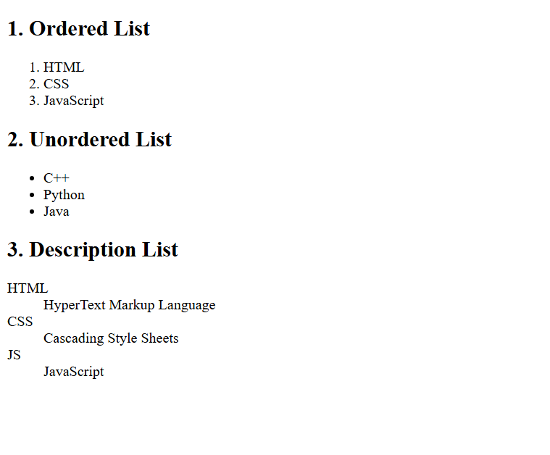

Some points to remember:

- <ol> → Ordered List (numbered)
- <ul> → Unordered List (bullets)
- <dl> → Description List
- <li> → List item
- <dt> → Description term
- <dd> → Description/details of the term

